25 Port 1U Rackmount CAT3/TELCO 6-Pin Patch Panel (PPAN-25-T)
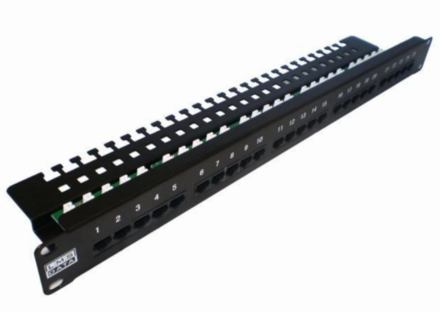

Description:

The LMS Data PPAN-25-T is 25 Port enhanced CAT3 and Telecommunications Patch Panel for working in low bandwidth applications of that of legacy PABX Telco applications.

Fully certified to CAT3/Telco standards allowing typical voice call cables to be terminated and thus patched via the 6-PIN front connection ports.

Long-life, nickel plated female ports are coupled with a vertical designed Krone(tm) IDC terminal IDC together with rear cable management bar and tabs.

Key Features:
- Certified CAT3/TELCO 25 Way Patch Panel
- Standard 6-Pin Ports with Krone(tm) IDC Punchdown
- 1u High means it fits in the smallest of data cabinets
- Part of the Synthesis 25-Year Warranty Solution

Applications:
- Office, Education and Home Structured Cabling Installs
- Ideal for Gigabit Ethernet (1000Mbps) Data Networks
- Create fault tolerant LANs by simply patching ports

Product Code:
- Part Number: PPAN-25-T
- EAN: 8400800013279
- Weight: 1 Kg approx.

Technical Specifications:
- Port Count：25 Ports UTP
- Dimensions：1U 19-Inch Design Format
- Design： 6-Pin Telco Ports, Numbered
- Performance：ISO/IEC-11801
- Ports/IDC Connects：Nickel and Phosphor Bronze
- Port Identification：Numbered
- Fixings： Supplied M6 Nuts and Bolts
* Specifications and product design are subject to change. E&OE.

